The Norwegian Sunday walk
This position paper proposes looking at the Norwegian “Sunday walk” as an interesting case for shedding light on the experience of being out in the forest, considering key elements such as context and knowledge. Understanding the experience is important in uncovering the potential for technology support. What follows is not a presentation of research, but a presentation of considerations made by a scientist in her spare time as she walks the local forest (for instance picking mushrooms). The main focus is not so much on technology use as the practice to which technology use (or non-use) (Harmon 2015) should relate
I will briefly outline key characteristics of the practice in question. What is addressed here is walking more than hiking, although a Sunday walk may be several hours long, often with hills and sometimes mountains. For simplicity, we will use the term “Sunday walk” for any walk made for purposes of recreation in one way or other, whether is actually Sunday or not.
Outdoor recreation on a Sunday in Norway typically takes place in the forest area surrounding the city. You will find people out with family, friends or both, and you will find many solitary walkers. You will find people out to exercise, relax, be social, pick berries, mushrooms or flowers, take photos, find orienteering posts, walk their dog, take the kids to feed the ducks, have a swim, use their mountain bike, go cross-country skiing, have a picnic, put up a tent and camp for a day or two, and/or visit the little forest restaurant serving coffee and waffles. You will find paths well maintained by municipal employees as well as volunteers. Main paths are typically prepared for skiing in winter, and some of them are lit in afternoons and evenings during winter. (In middle Norway we have approximately 4 hours of full daylight around Christmas. Far north in the country you do not get more than dusk during mid winter.). There will be a network of smaller paths, changing over time as people find new favourite routes and new people discover and start using another part of the forest.
The forest close to the city thus serves as a grand outdoor recreation area, facilitated by the legally defined “every man’s right” to walk in any forest area (except in somebody’s garden or crop). On other man’s forest property (which could be public or private) there are rules for how long you may stay if you put up a tent (3 days in the same spot), at what times of the year you are allowed to light a fire, etc., but generally you may walk anywhere you like as long as you do not break trees and cause other harm to the environment. This means berry- and mushroom-picking, walking, running, cycling and skiing are all allowed. (Fishing and hunting are regulated, but mostly fishing is allowed for a fee). The “every man’s right” should be regarded as fundamental to the experience of the Norwegian Sunday walker, as it establishes a high degree of freedom as something we may take for granted.
It seems fair to regard it as an overarching objective for most Sunday walkers to get the most out of one’s trip to the forest. What this means is of course individual (depending on your interests), but the possibilities vary. Success criteria for a Sunday may be related to some initial objective (walking the long round, reaching the highest point, picking 10 litres of lingonberries, finally getting out after a week in the office), and/or being able to adapt and utilize the opportunities to create a good experience for yourself should there turn up reasons to change plans. Having a plan in advance makes it easier to bring the right equipment, but an experienced Sunday walker might bring things that can serve several purposes. Flexibility is key if the planning was not optimal: the pockets of your jacket can be used for mushrooms, your thermos for lingonberries, if you really want to. Often several objectives can be met on the same trip: Getting exercise is a nice side effect of picking mushrooms, and can be boosted by choosing a more hilly/challenging route.

As an arena for activity that may be more or less supported by technology, this is a complex setting offering a myriad of contexts – different to people in different roles (e.g. the volunteer cutting trees along the paths, the kindergarden teacher following a group of 5 year olds on a daytrip, the running enthusiast trying to break her record time on her favourite route), but also to each individual acting within different contexts across otherwise rather similar situations. I will use the solitary mushroom picker as an example.
Consider stumbling upon a mushroom. You may consider this mushroom as
- an uninteresting part of the general vegetation. It would be a pity to stop jogging and start collecting mushrooms.
- a nice motive for an aestetically pleasing photograph in a Google Pictures album to share from this walk. Actually, you decide right now that you will create such an album and take a route home likely to include a varied selection of mushrooms
- a cool idea for a snapshot to send a friend as part of a joke you just thought out. You send the picture in a message and hope for some bantering.
- maybe poisonous? Would be nice to know. You look it up on Google and consider sending a picture to your friend the mushroom-expert
- definitely edible and will be part of the filling of a quiche (of which you will later take some pictures and share on Facebook, or share the recipe on your blog). The direction to take in the forest right now is further into this terrain to see if there are more of this food around.
- a rare kind of mushroom that the kids might like to see. You bring it home for them to have a look.
A given person might perceive the mushroom in several of these ways (and many more) depending on her objectives that day, the inclinations of the moment, the surrounding conditions.
During a Sunday walk there may be switching from one kind of walk to another (I.e. a picnic turning into a mushroom-picking endeavour), maybe temporarily. The objective affects the activity. Once the decision is made, or considered, to look for mushrooms, the visual focus of the walker changes, both in terms of direction (looking more along the ground), visual patterns of interest, and focal area/distance from the path.
The understanding of context as presented by Dourish (2004) may shed light on the experience of relating to several possible plans and objectives during a Sunday walk. Dourish argues that context is a relational property between objects and activities, cannot be defined and delineated in advance and is not stable but particular to each occasion of activity or action, and that context and content are not separable entities; context is actively produced, maintained and enacted in the course of the activity at hand.
Another important aspect of the experience of the Sunday walker is knowledge. Knowledge enables the Sunday walker to engage in activity linked to a certain context. Mushrooms are a good example in this regard. (Interesting: where to find them. Extremely important: Which ones are poisonous) Space, temporality and granularity are interesting dimensions of the knowledge relevant to a Sunday walk. Different contexts have different “maps” in time and space.
In certain contexts, areas are more interesting than paths. Looking for mushrooms, you focus on the path to get somewhere (and perhaps look for mushrooms on the way, making the path a special kind of area!), but reaching interesting terrain, the mushroom picker needs to try and cover the area without missing interesting spots. Knowledge about the forest and which areas tend to be good for mushrooms is something that the mushroom picker builds over time, becoming an expert not only on types of terrain but on the particular local area. There are temporal changes – some regular, others varying (what is normal for October in this area, how is this October). There are natural changes, e.g. related to the weather, and there are man made changes to the forest (e.g. trees cut in a large area, a path recently mended). The state of certain resources in specific places or areas may change (restaurant closed, picnic area too crowded).
A Sunday walker may be a participant in several communities for which knowledge about the forest would be relevant and welcome e.g. through social media. Knowledge about resources that are more or less unlimited, may be shared at little cost – for instance news about good skiing conditions in a certain part of the forest. For knowledge about limited resources for which there may be competition, it is different: There may be knowledge sharing but also hoarding. In this case, the granularity of the knowledge is relevant. You may want to share your insight that this is actually a good season for chanterelles in the forest. You might consider giving a hint about what areas in the forest are recommended for chanterelles. Finally, regarding knowledge about exactly which spots in this forest have been great for chanterelles over the last years, the mushroom picker might consider to include a sentence about it in her last will. But it is unlikely!
To conclude, for the Technology on the Trail workshop, I propose to include the Norwegian Sunday walk into the repository of information related to the workshop topic area, believing it represents an interesting case as a culturally established practice and with the all-important ”every man’s right” as a great enabler. This position paper used mushroom picking as an example of a certain type of walk, but there are many, many more.

Dourish, Paul. “What We Talk about When We Talk about Context.” Personal and Ubiquitous Computing 8, no. 1 (2004): 19–30.

Harmon, Mary E. “Computing as Context: Experiences of Dis/Connection Beyond the Moment of Non/Use.” University of California, Irvine, 2015.

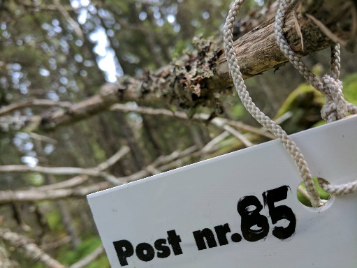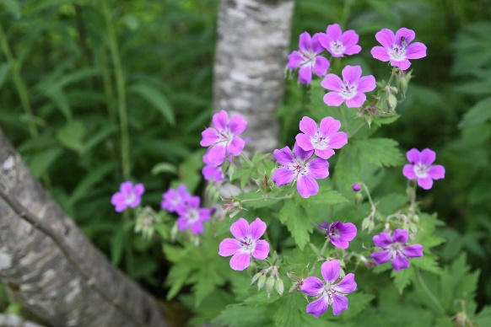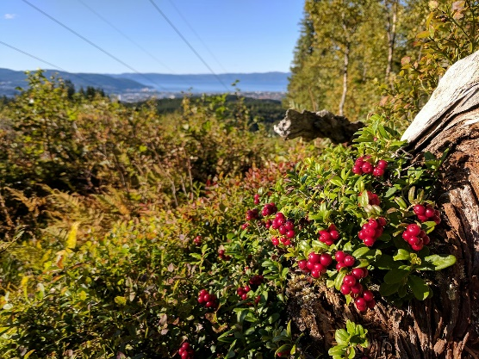
(photos taken on the author’s Sunday walks)

